**9. Design an automatic night lighting system (with 4 connected led’s) such the system is only activated when the master control switch is pressed. a) Below 50% value of full brightness all LED’s constantly ON. b) Above 50% value of full brightness only first LED is ON.**

**CIRCUIT DAIGRAM:**

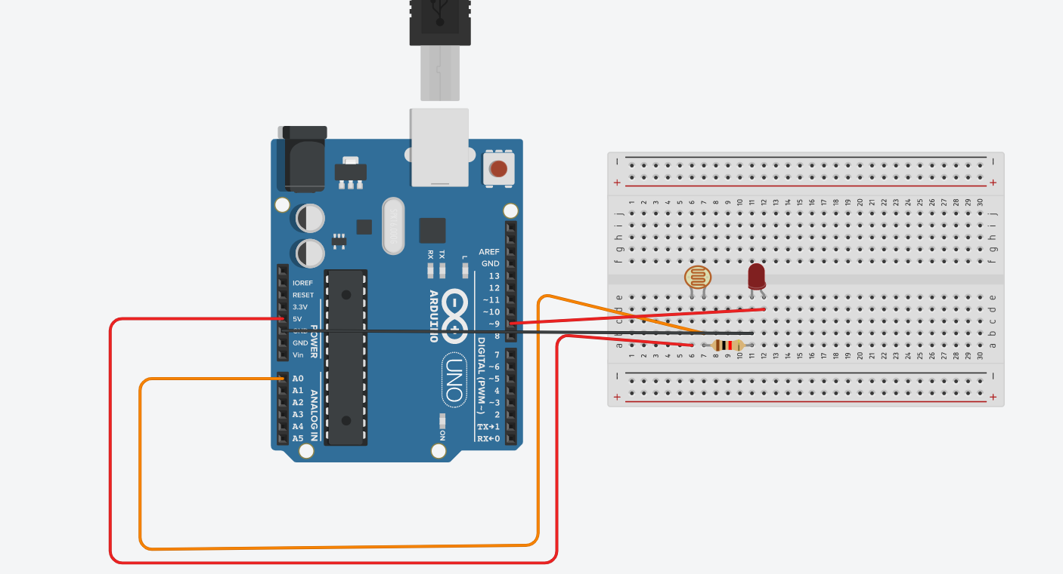

**THEORY:**

A photoresistor is a light-controlled variable resistor. The resistance of a photoresistor decreases with increasing incident light intensity; in other words, it exhibits photoconductivity. A photoresistor can be applied in light-sensitive detector circuits, and light-activated and dark-activated switching circuits. In this case Arduino provides the input to photoresistor and output to led.

**OBSERVATION:**

When light intensity is low the led light glows below 50% brightness and when the intensity of light increases the led glows above 50% brightness.

**PROBLEMS AND TROUBLESHOOTING:**

1. Wires should be connected should be properly.
2. Positive and negative pins should be checked before connections.

**PRECAUTIONS:**

1. Wires should be continuous, there should be no breakage.
2. Ports for the connection should be right.

**LEARNING OUTCOMES:**

1. Came to know about Arduino.
2. Came to kown about using photoresistor.

**CODE:**

int ledpin = 9;

int ldrpin = 1;

int value = 0;

void setup()

{

Serial.begin(9600);

}

void loop()

{

value = analogRead(ldrpin);

value = constrain(value,400,500);

value = map(value,400,500,255,0);

Serial.println(value);

analogWrite(ledpin, value);

delay(200);

}